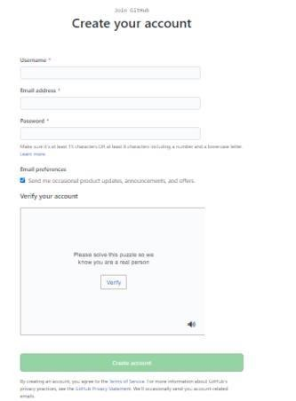

INTRODUCTION TO GITHUB

SOFTWARE CONSTRUCTION & DEVELOPMENT

Lab 13

# OBJECTIVE

Introduction to GitHub by creating Git repository and cloning its configuration to eclipse project.

# LAB TASK:

* Create account on GitHub. Upload any of your Java Project files and perform commit, push, pull and merge operations.

**STEP 1:**

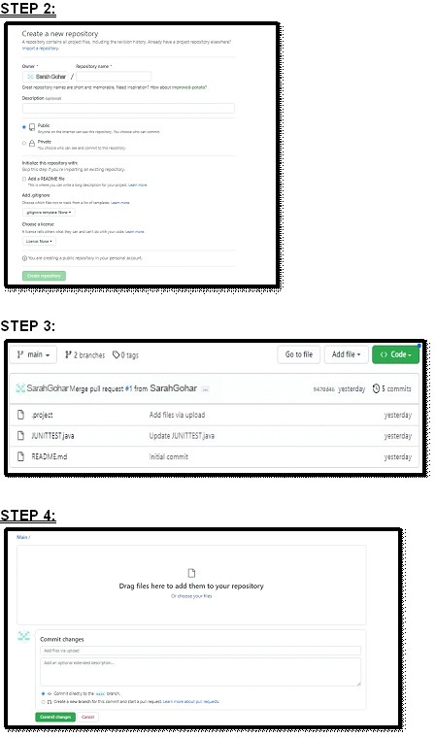

SOFTWARE CONSTRUCTION & DEVELOPMENT

Lab 13

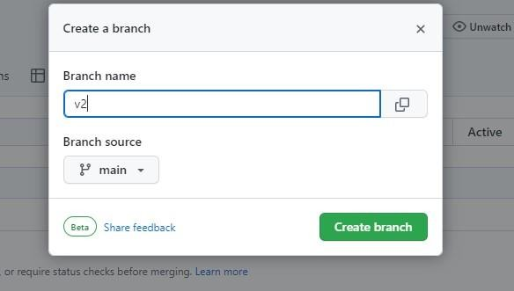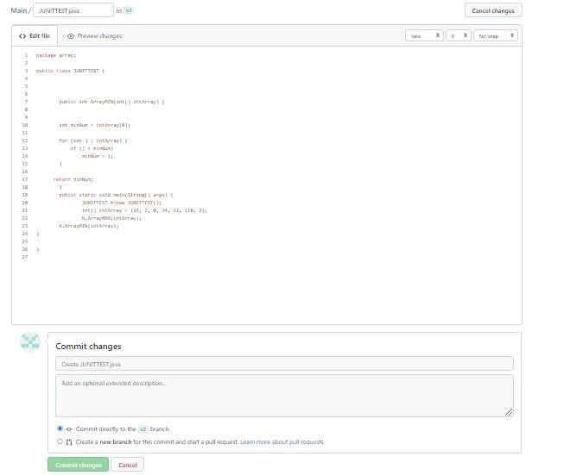

**STEP 5:**

SOFTWARE CONSTRUCTION & DEVELOPMENT

Lab 13

**STEP 6:**

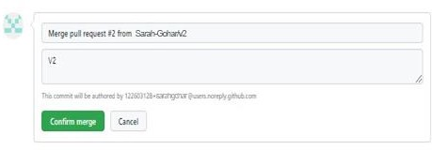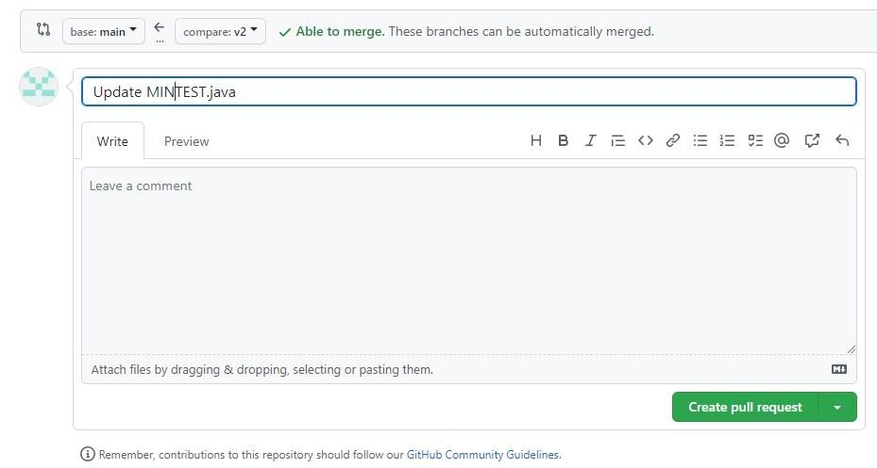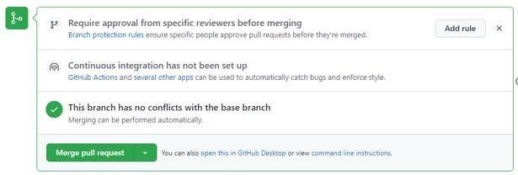

SOFTWARE CONSTRUCTION & DEVELOPMENT

Lab 13

**STEP 7:**

**STEP 8:**

**STEP 9:**

**STEP 10:**



SOFTWARE CONSTRUCTION & DEVELOPMENT

Lab 13